

Name: Aashish Bansal

Registration No.: 19BIT0346

Course Code: ITE1002

Course Name: Web Technologies

Faculty Name: Prof. Mareeshwari V

Theory Slot: G1

Lab Slot: L59 + L60

Table of Contents

Question 1: Introduction to HTML 5

Part a 5

HTML Code 5

Code URL 5

Code Screenshot 5

Output Screenshot 5

Part b 5

HTML Code 6

Code Screenshot 7

Code URL 7

Output Screenshot 7

Part c 7

HTML Code 7

Code Screenshot 8

Code URL 8

Output Screenshot 8

Part d 8

HTML Code 8

Code Screenshot 9

Code URL 10

Output Screenshot 10

Part e 10

HTML Code 10

Code Screenshot 11

Code URL 11

Output Screenshot 11

Part f 11

HTML Code 11

Code Screenshot 12

Code URL 12

Output Screenshot 12

Question 2: 12

Part a 12

HTML Code 13

Code URL 13

Output Screensh 13

Code Screenshot 13

Part b 13

HTML Code 14

Code URL 14

Output Screenshot 15

Code Screenshot 15

Part c 15

HTML Code 16

Code URL 16

Output Screenshot 16

Code Screenshot 17

Part d 17

HTML Code 17

Code URL 17

Output Screenshot 18

Code Screenshot 18

Part e 18

HTML Code 18

Code URL 19

Output Screenshot 19

Code Screenshot 20

Part f 20

HTML Code 20

Code URL 21

Output Screenshot 21

Code Screenshot 21

Part g 21

HTML Code 21

Code URL 22

Output Screenshot 22

Code Screenshot 22

Part h 22

HTML Code 23

Code URL 23

Output Screenshot 23

Code Screenshot 24

Part i 24

HTML Code 24

Code URL 24

Output Screenshot 25

Code Screenshot 25

Part j 25

HTML Code 25

Code URL 26

Output Screenshot 26

Code Screenshot 26

Part k 26

HTML Code 27

Code URL 27

Output Screenshot 28

Code Screenshot 28

Part l 28

HTML Code 28

Code URL 29

Output Screenshot 29

Code Screenshot 30

Part m 30

HTML Code 30

Code URL 30

Output Screenshot 31

Code Screenshot 31

Part n 31

HTML Code 31

Code URL 31

Output Screenshot 31

Code Screenshot 31

Assessment 1

# Question 1: Introduction to HTML

## Part a

Question: Create a webpage that prints your name to the screen.

### HTML Code

<!DOCTYPE html>

<html>

<head>

<title></title>

</head>

<body>

<h1>Aashish Bansal</h1>

<h2>19BIT0346</h2>

</body>

</html>

### Code URL

file:///C:/Aashish/VIT/Semester%203/ITE1002%20PC%20Web%20Technologies%20Laboratory/Assessment%201/19BIT0346%201a.html

### Code Screenshot

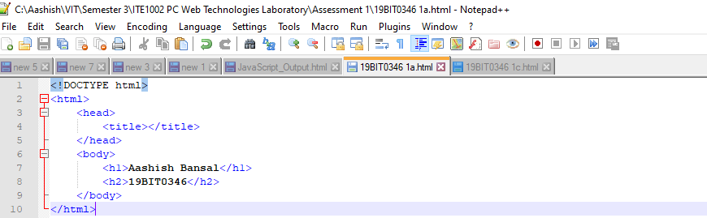

### Output Screenshot

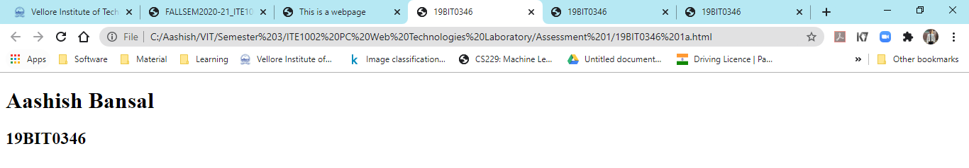

## Part b

Question: Create a webpage that prints the numbers 1 - 10 to the screen.

### HTML Code

<!DOCTYPE html>

<html>

<head>

<title></title>

</head>

<body>

<h1>Aashish Bansal</h1>

<h2>19BIT0346</h2>

<h4>Create a webpage that prints the numbers 1 - 10 to the screen.</h4>

<p>

1<br>

2<br>

3<br>

4<br>

5<br>

6<br>

7<br>

8<br>

9<br>

10<br>

</p>

</body>

</html>

### Code Screenshot

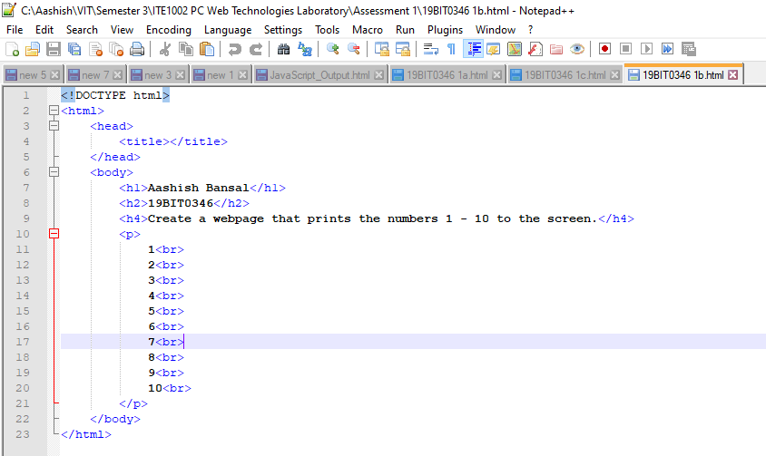

### Code URL

file:///C:/Aashish/VIT/Semester%203/ITE1002%20PC%20Web%20Technologies%20Laboratory/Assessment%201/19BIT0346%201b.html

### Output Screenshot

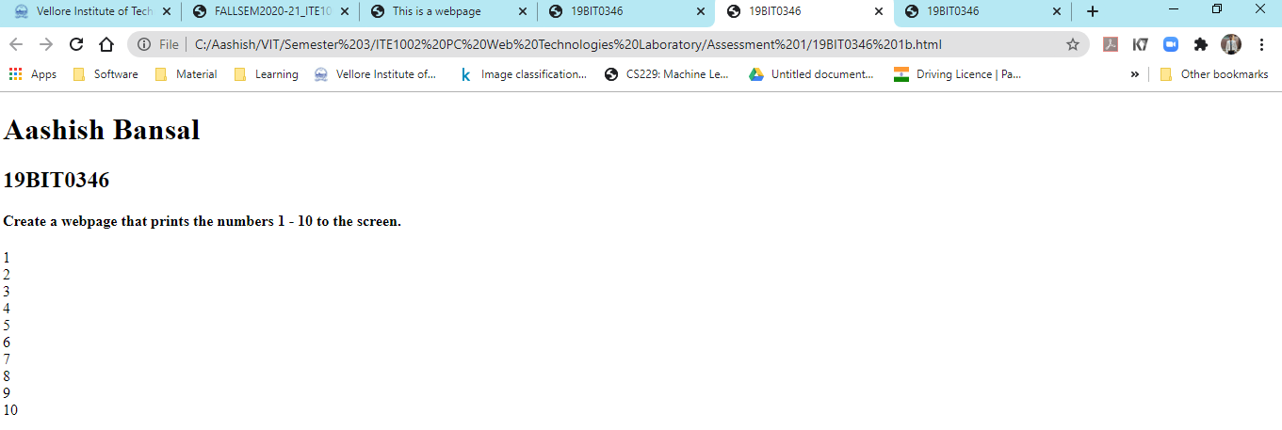

## Part c

Question: Create a webpage and set its title to "This is a webpage".

### HTML Code

<!DOCTYPE html>

<html>

<head>

<title>This is a webpage</title>

</head>

<body>

<h1>Aashish Bansal</h1>

<h2>19BIT0346</h2>

<h4>Create a webpage and set its title to "This is a webpage".</h4>

</body>

</html>

### Code Screenshot

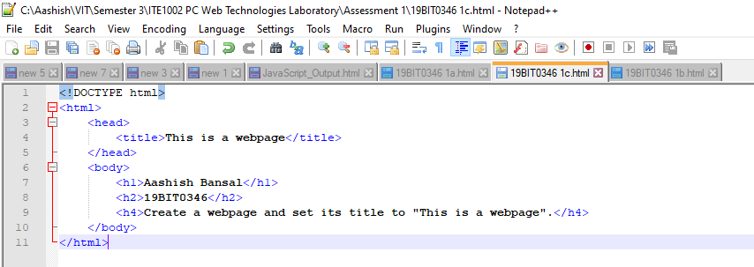

### Code URL

file:///C:/Aashish/VIT/Semester%203/ITE1002%20PC%20Web%20Technologies%20Laboratory/Assessment%201/19BIT0346%201c.html

### Output Screenshot

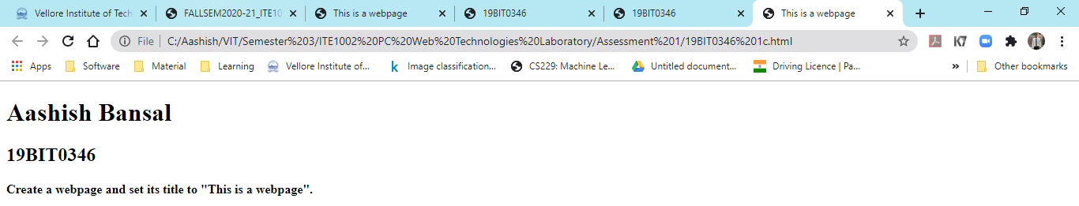

## Part d

Question: Create a webpage that prints the message "When was this webpage created? Check page's title for the answer." to the screen, and set the title of the page to the current date.

### HTML Code

<!DOCTYPE html>

<html>

<head>

<title>

<script>

document.getElementById("date").innerHTML = Date();

</script>

</title>

</head>

<body>

<h1>Aashish Bansal</h1>

<h2>19BIT0346</h2>

<h4>Create a webpage that prints the message "When was this webpage created?<br>

Check page's title for the answer." to the screen, and set the title of the page to<br>

the current date.

</h4>

<p>When was this webpage created?</p>

<p id="date"></p>

<script>

document.title=new Date();

document.getElementById("date").innerHTML = Date();

</script>

</body>

</html>

### Code Screenshot

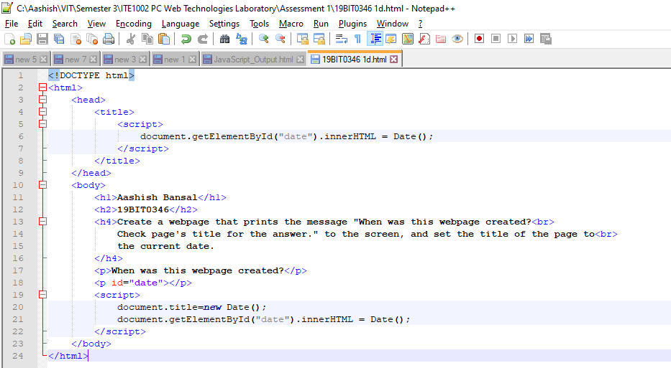

### Code URL

file:///C:/Aashish/VIT/Semester%203/ITE1002%20PC%20Web%20Technologies%20Laboratory/Assessment%201/19BIT0346%201d.html

### Output Screenshot

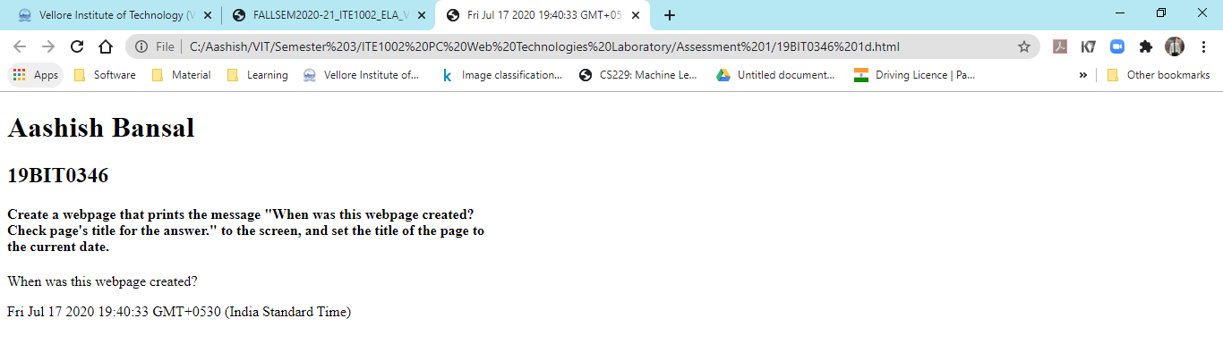

## Part e

Question: Create a webpage that prints any text of your choice to the screen; do not include a head section in the code

### HTML Code

<!DOCTYPE html>

<html>

<body>

<h1>Aashish Bansal</h1>

<h2>19BIT0346</h2>

<h4>

Create a webpage that prints any text of your choice to the screen; do not<br>

include a head section in the code.

</h4>

For this webpage, the file name has been displayed as the name of the file since the<br>

head section is missing.

</body>

</html>

### Code Screenshot

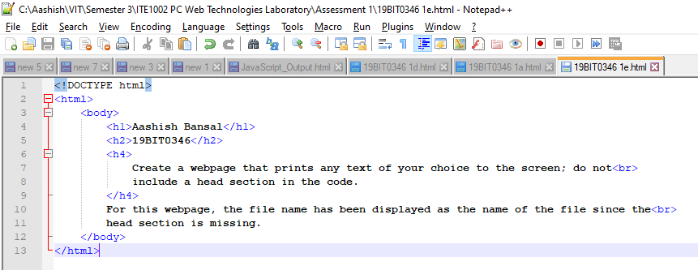

### Code URL

file:///C:/Aashish/VIT/Semester%203/ITE1002%20PC%20Web%20Technologies%20Laboratory/Assessment%201/19BIT0346%201e.html

### Output Screenshot

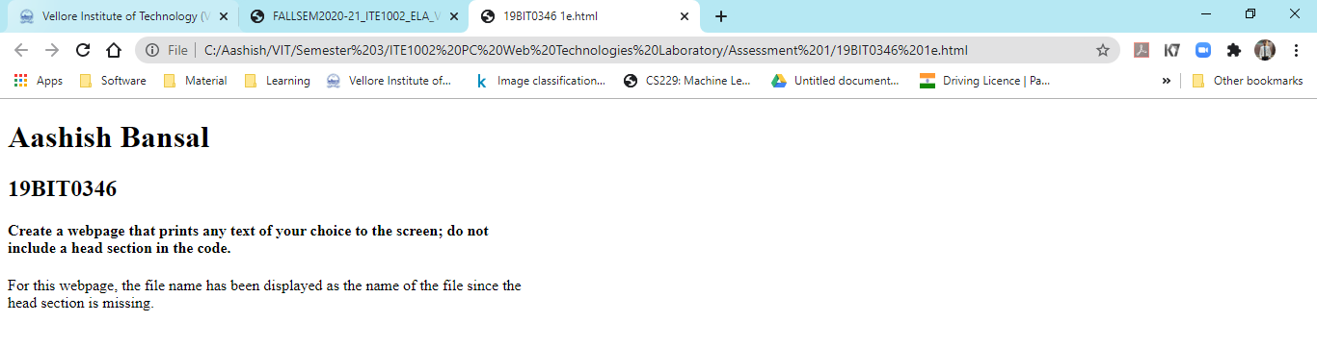

## Part f

Question:

Create a webpage which keeps track of the browsers information and do the following

* refreshes its page in 5 seconds,
* expires in a duration of time

### HTML Code

<!DOCTYPE html>

<html>

<head>

<title>19BIT0346</title>

<meta http-equiv="refresh" content="5; URL=C:\Aashish\VIT\Semester 3\ITE1002 PC Web Technologies Laboratory\Assessment 1\19BIT0346 1f.html">

<meta http-equiv="refresh" content="6000;URL=C:\Aashish\VIT\Semester 3\ITE1002 PC Web Technologies Laboratory\Assessment 1\19BIT0346 1f.html" />

</head>

<body>

<h1>Aashish Bansal</h1>

<h2>19BIT0346</h2>

<h4>

Create a webpage which keeps track of the browsers information and do the following<br>

• refreshes its page in 5 seconds,<br>

• expires in a duration of time

</h4>

</body>

</html>

### Code Screenshot

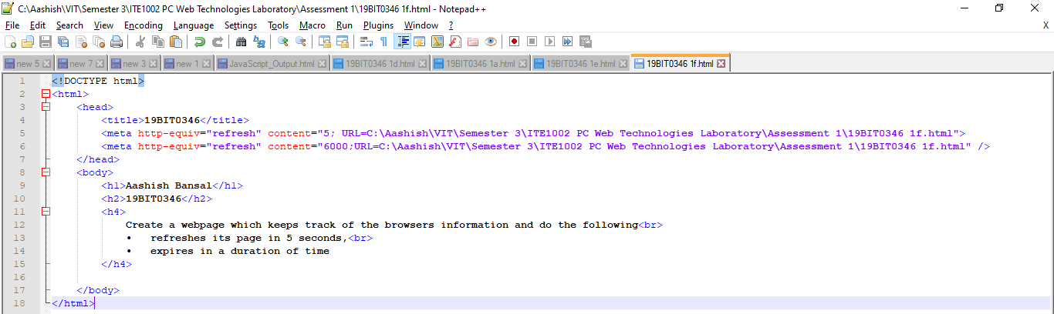

### Code URL

file:///C:/Aashish/VIT/Semester%203/ITE1002%20PC%20Web%20Technologies%20Laboratory/Assessment%201/19BIT0346%201f.html

### Output Screenshot

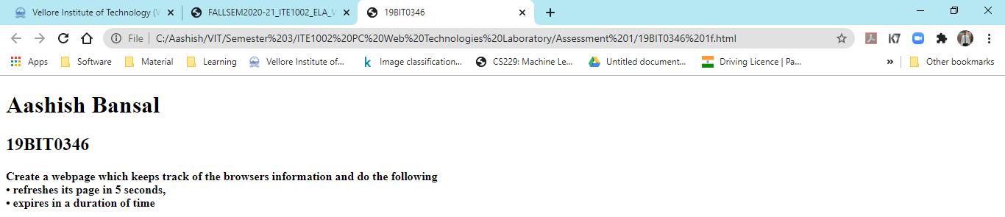

# Question 2:

## Part a

Question:

Print your name in green.

### HTML Code

<!DOCTYPE html>

<html>

<head>

<title>19BIT0346 2a</title>

</head>

<body>

<h1>Aashish Bansal 19BIT0346 Question 2a</h1>

<h4>Print your name in green.</h4>

<p style="color:green;">Aashish Bansal</p>

</body>

</html>

### Code URL

file:///C:/Aashish/VIT/Semester%203/ITE1002%20PC%20Web%20Technologies%20Laboratory/Assessment%201/19BIT0346%202a.html

### Output Screensh

### Code Screenshot

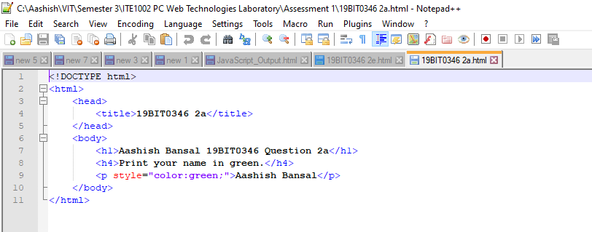

## Part b

Question:

Print the numbers 1 - 10, each number being a different colour.

### HTML Code

<!DOCTYPE html>

<html>

<head>

<title>19BIT0346 2b</title>

</head>

<body>

<h1>Aashish Bansal 19BIT0346 Question 2a</h1>

<h4>Print the numbers 1 - 10, each number being a different color.</h4>

<p>Printing 10 numbers with different colours:</p>

<font color="red">1</font><br>

<font color="green">2</font><br>

<font color="blue">3</font><br>

<font color="brown">4</font><br>

<font color="purple">5</font><br>

<font color="gray">6</font><br>

<font color="#0008B">7</font><br>

<font color="#688e23">8</font><br>

<font color="#800000">9</font><br>

<font color="#008080">10</font><br>

</body>

</html>

### Code URL

file:///C:/Aashish/VIT/Semester%203/ITE1002%20PC%20Web%20Technologies%20Laboratory/Assessment%201/19BIT0346%202b.html

### Output Screenshot

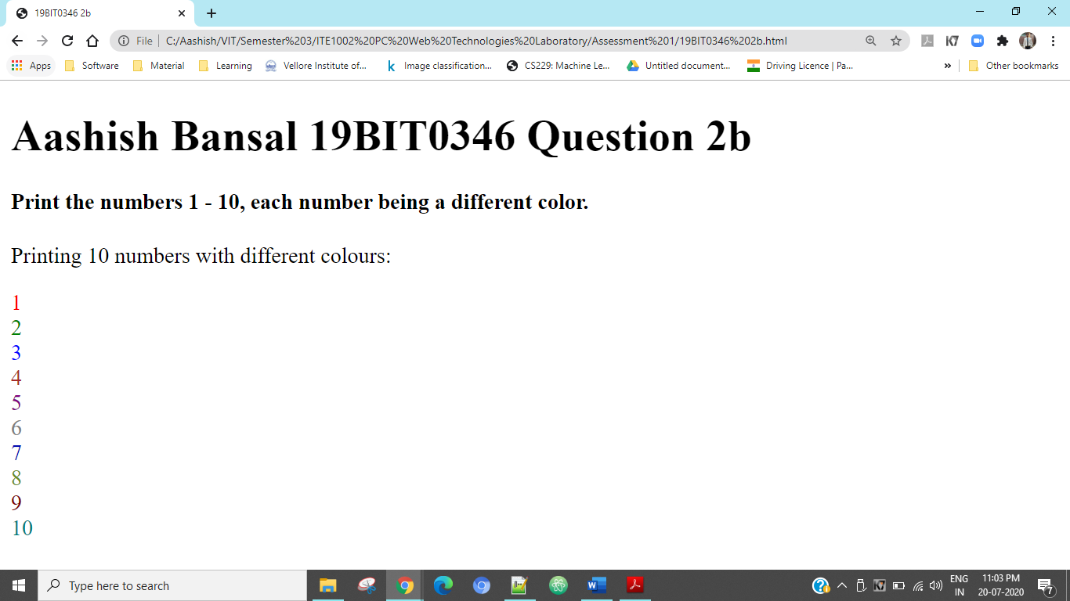

### Code Screenshot

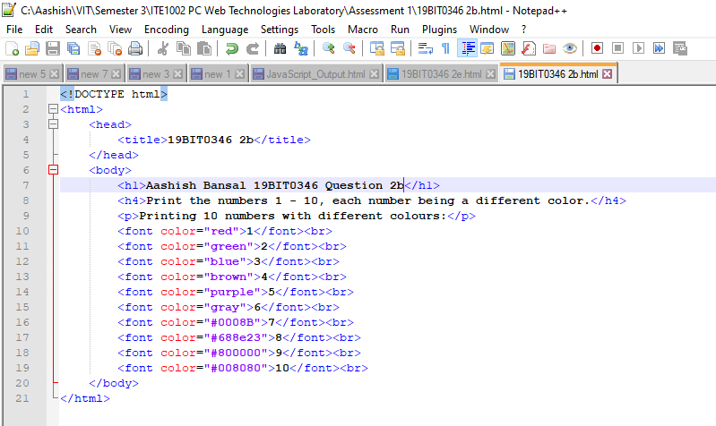

## Part c

Question:

Prints your name in a Tahoma font.

### HTML Code

<!DOCTYPE html>

<html>

<head>

<title>19BIT0346 2c</title>

</head>

<body>

<h1>Aashish Bansal 19BIT0346 Question 2a</h1>

<h4>Prints your name in a Tahoma font.</h4>

<p style="font-family:'Tahoma'">Aashish Bansal</p>

</body>

</html>

### Code URL

file:///C:/Aashish/VIT/Semester%203/ITE1002%20PC%20Web%20Technologies%20Laboratory/Assessment%201/19BIT0346%202c.html

### Output Screenshot

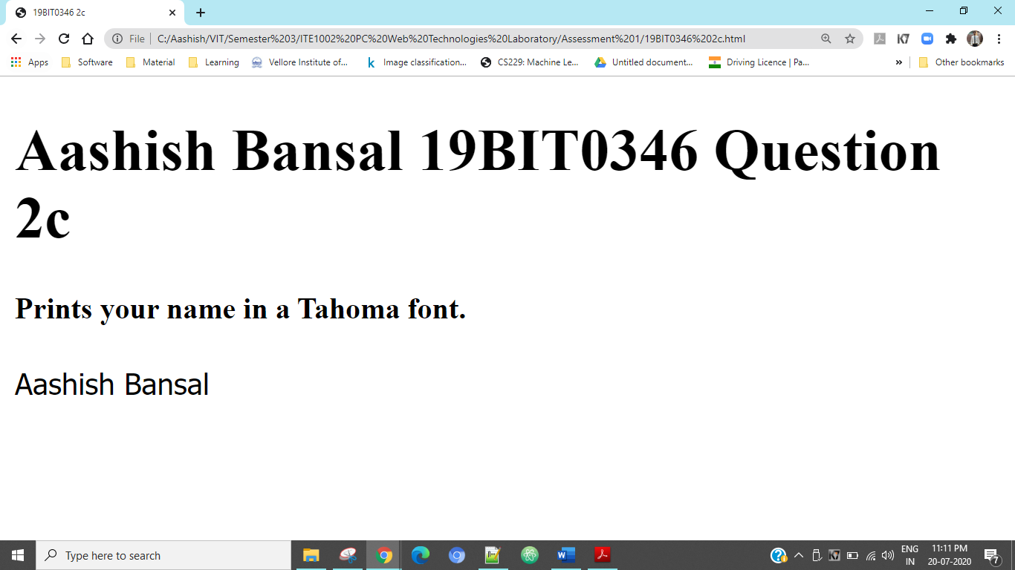

### Code Screenshot

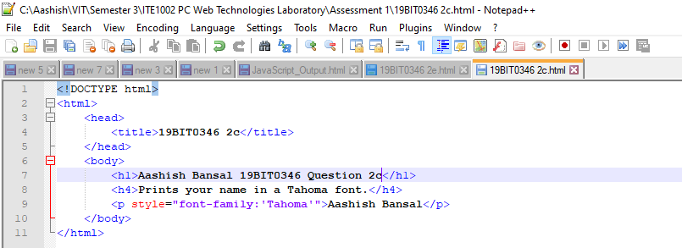

## Part d

Question:

Display a part of a word with bold underline.

### HTML Code

<!DOCTYPE html>

<html>

<head>

<title>19BIT0346 2c</title>

</head>

<body>

<h1>Aashish Bansal 19BIT0346 Question 2a</h1>

<h4>Display a part of a word with bold underline.</h4>

<p><b>Aashish</b> <u>Bansal</u></p>

<p><b><u>19BIT0346</b></u></p>

</body>

</html>

### Code URL

file:///C:/Aashish/VIT/Semester%203/ITE1002%20PC%20Web%20Technologies%20Laboratory/Assessment%201/19BIT0346%202d.html

### Output Screenshot

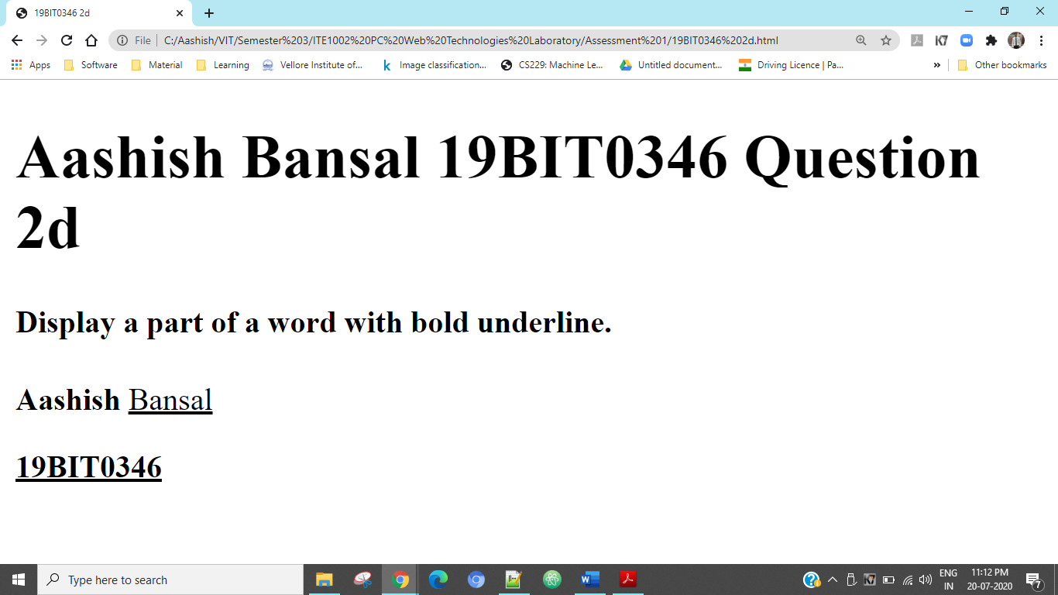

### Code Screenshot

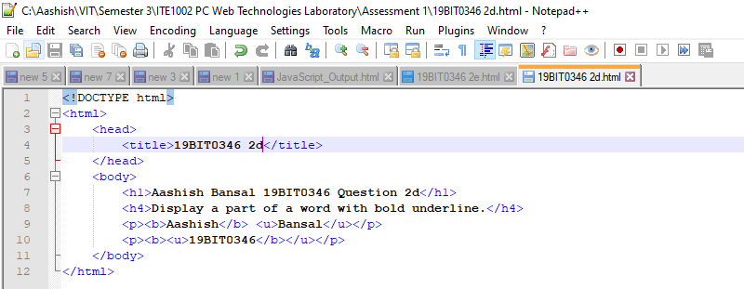

## Part e

Question:

Print a paragraph with 4 - 5 sentences. Each sentence should be a different font

### HTML Code

<!DOCTYPE html>

<html>

<head>

<title>19BIT0346 2e</title>

</head>

<body>

<h1>Aashish Bansal 19BIT0346 Question 2e</h1>

<h4>Print a paragraph with 4 - 5 sentences. Each sentence should be a different font</h4>

<p style="font-family:'Calibri'">Topic sentences are similar to mini thesis statements. Like a thesis statement, a topic sentence has a specific main point.</p>

<p style="font-family:'Arial Rounded MT Bold'">Whereas the thesis is the main point of the essay, the topic sentence is the main point of the paragraph.</p>

<p style="font-family:'Castellar'">Like the thesis statement, a topic sentence has a unifying function.</p>

<p style="font-family:'Tahoma'">But a thesis statement or topic sentence alone doesn’t guarantee unity.</p>

<p style="font-family:'Courier New'">An essay is unified if all the paragraphs relate to the thesis, whereas a paragraph is unified if all the sentences relate to the topic sentence.</p>

</body>

</html>

### Code URL

file:///C:/Aashish/VIT/Semester%203/ITE1002%20PC%20Web%20Technologies%20Laboratory/Assessment%201/19BIT0346%202e.html

### Output Screenshot

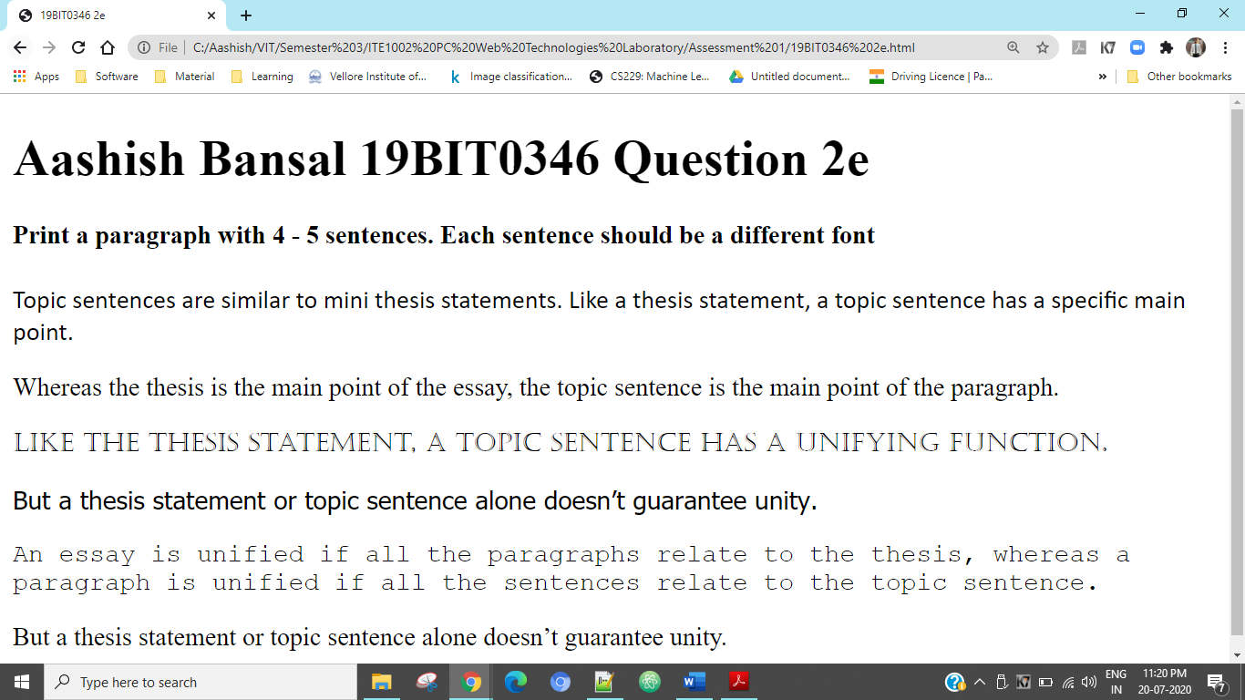

### Code Screenshot

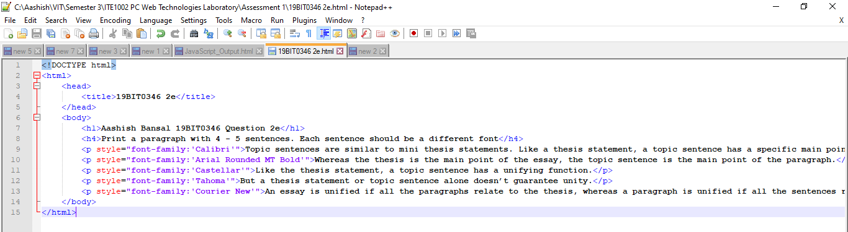

## Part f

Question:

Print a paragraph that is a description of a book; include the title of the book as well as its author. Names and titles should be underlined, adjectives should be italicized and bolded.

### HTML Code

<!DOCTYPE html>

<html>

<head>

<title>19BIT0346 2f</title>

</head>

<body>

<h1>Aashish Bansal 19BIT0346 Question 2f</h1>

<h4>Print a paragraph that is a description of a book; include the title of the book as well as its author. Names and titles should be underlined,

adjectives should be italicized and bolded.</h4>

<h1>The Lord of the Rings</h1>

<h2>J.R.R. Tolkien</h2>

<p><i>The Lord of the Rings</i>, fantasy novel by <i>J.R.R. Tolkien</i> initially published in <i>three</i> parts as <i>The Fellowship of the Ring (1954)</i>,

<i>The Two Towers (1955)</i>, and <i>The Return of the King (1955)</i>. The novel, set in the <i>Third Age</i> of Middle Earth, formed a sequel to Tolkien’s

<i>The Hobbit (1937)</i> and was succeeded by his posthumous <i>The Silmarillion (1977)</i>. The Lord of the Rings is the saga of a group of sometimes

reluctant heroes who set forth to save their world from <i>consummate</i> evil. Its many worlds and creatures were drawn from Tolkien’s extensive

knowledge of philology and folklore.</p>

</body>

</html>

### Code URL

file:///C:/Aashish/VIT/Semester%203/ITE1002%20PC%20Web%20Technologies%20Laboratory/Assessment%201/19BIT0346%202f.html

### Output Screenshot

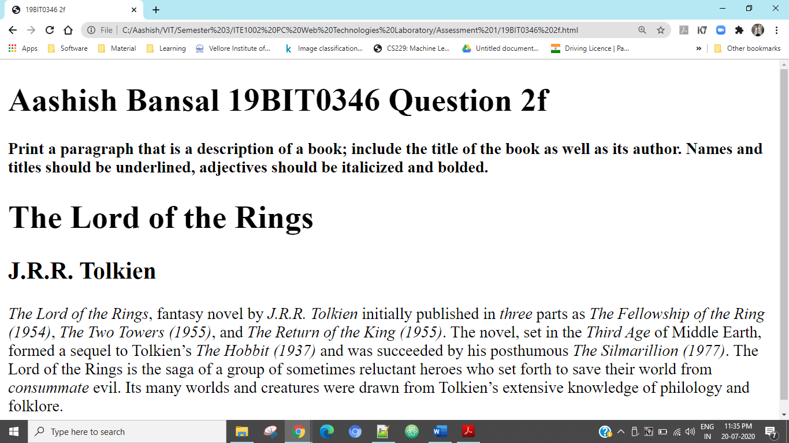

### Code Screenshot

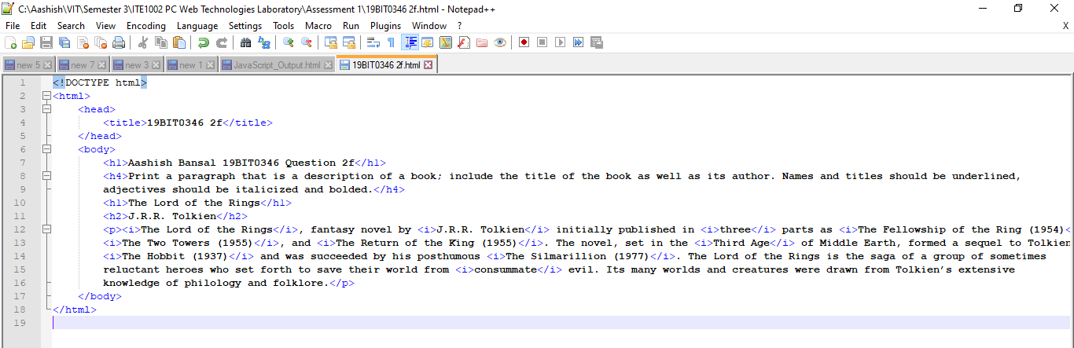

## Part g

Question:

Print your name to the screen with every letter being a different heading size.

### HTML Code

<!DOCTYPE html>

<html>

<head>

<title>19BIT0346 2g</title>

</head>

<body>

<h1>Aashish Bansal 19BIT0346 Question 2g</h1>

<h4>Print your name to the screen with every letter being a different heading size.</h4>

<h1>A</h1><h2>a</h2><h3>s</h3><h4>h</h4><h5>i</h5><h6>s</h6><h1>h</h1> <h2>B</h2><h3>a</h3><h4>n<h4><h5>s</h5><h6>a</h6><h1>l</h1>

</body>

</html>

### Code URL

file:///C:/Aashish/VIT/Semester%203/ITE1002%20PC%20Web%20Technologies%20Laboratory/Assessment%201/19BIT0346%202g.html

### Output Screenshot

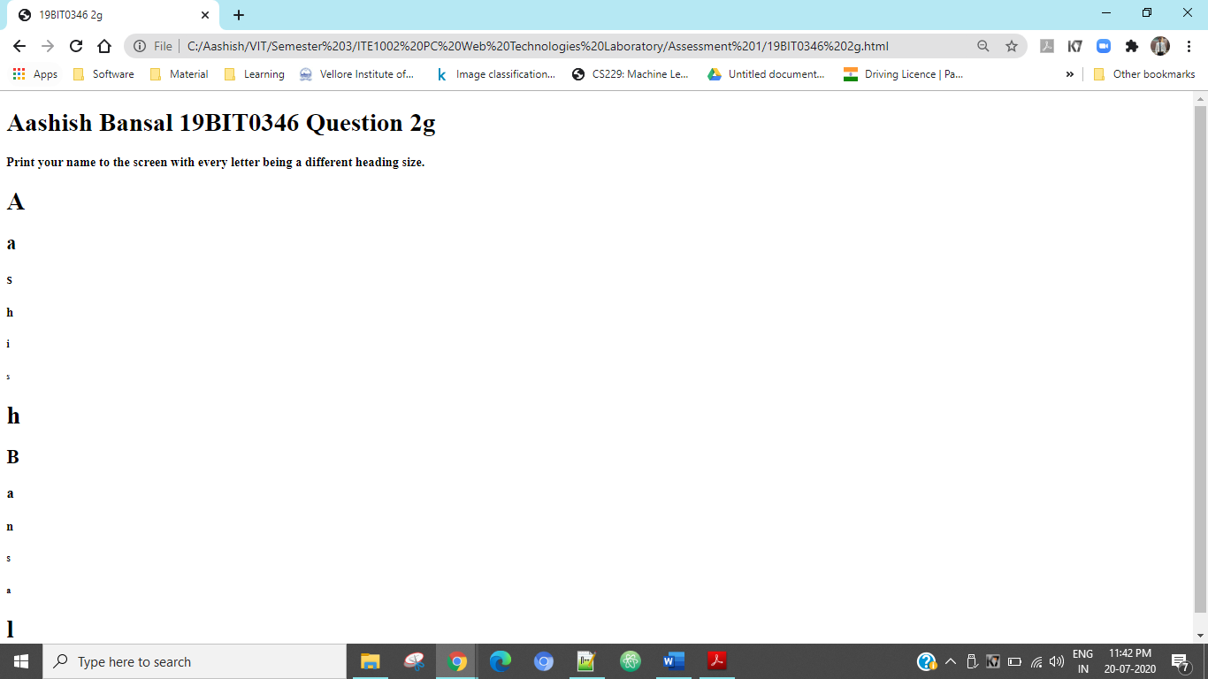

### Code Screenshot

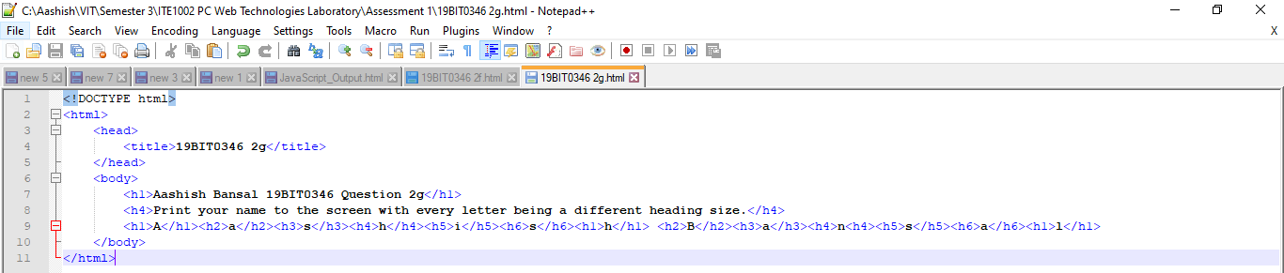

## Part h

Question:

Write a comment line on your code and make sure it is not displayed in the page.

### HTML Code

<!DOCTYPE html>

<html>

<head>

<title>19BIT0346 2h</title>

</head>

<body>

<h1>Aashish Bansal 19BIT0346 Question 2h</h1>

<h4>Write a comment line on your code and make sure it is not displayed in the page</h4>

The comment is below this line of the code and it is not being displayed.

<!--This is a comment.-->

</body>

</html>

### Code URL

file:///C:/Aashish/VIT/Semester%203/ITE1002%20PC%20Web%20Technologies%20Laboratory/Assessment%201/19BIT0346%202h.html

### Output Screenshot

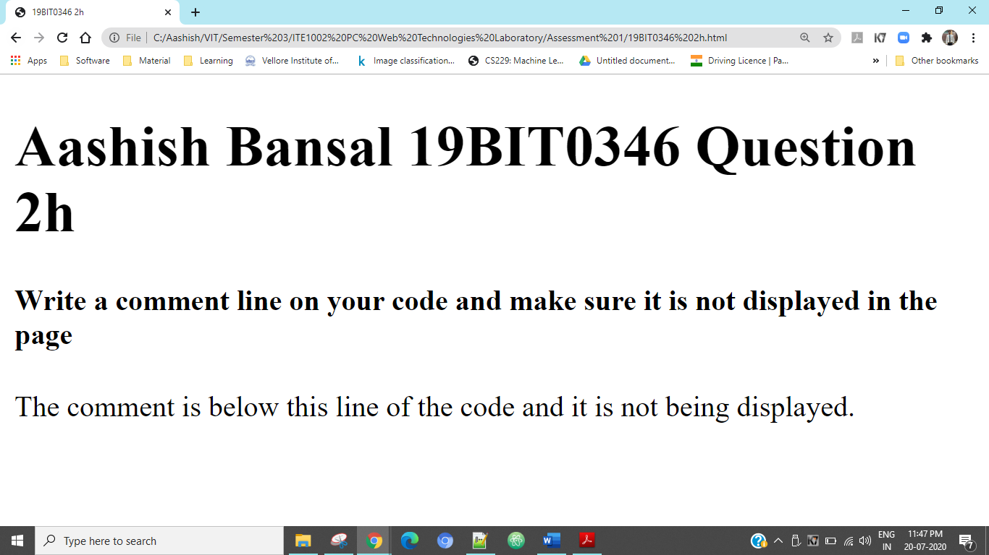

### Code Screenshot

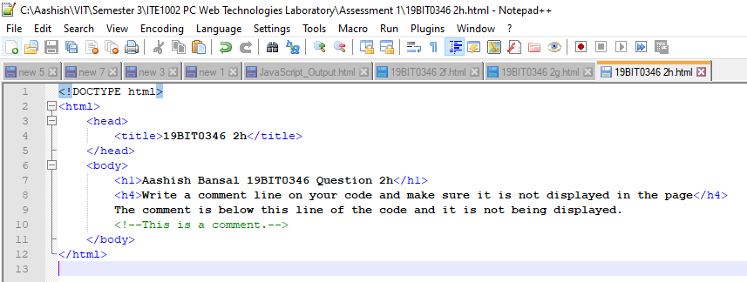

## Part i

Question:

Print a2+b2=2ab

### HTML Code

<!DOCTYPE html>

<html>

<head>

<title>19BIT0346 2i</title>

</head>

<body>

<h1>Aashish Bansal 19BIT0346 Question 2i</h1>

<h4>Print a2+b2=2ab</h4>

a<sup>2</sup>+b<sup>2</sup>=2ab

</body>

</html>

### Code URL

file:///C:/Aashish/VIT/Semester%203/ITE1002%20PC%20Web%20Technologies%20Laboratory/Assessment%201/19BIT0346%202i.html

### Output Screenshot

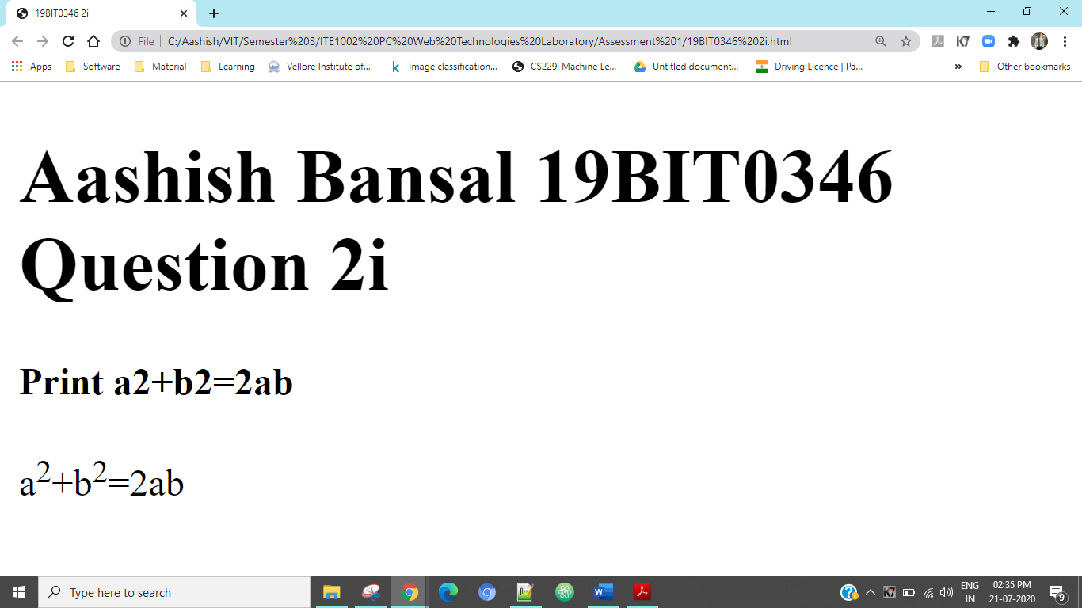

### Code Screenshot

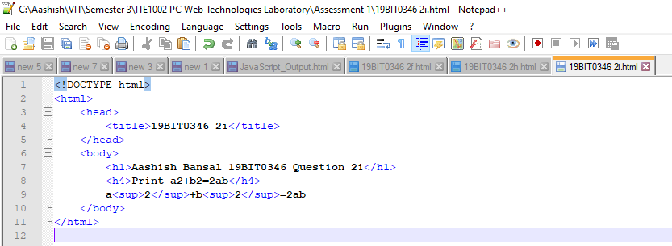

## Part j

Question:

Print H2O

### HTML Code

<!DOCTYPE html>

<html>

<head>

<title>19BIT0346 2j</title>

</head>

<body>

<h1>Aashish Bansal 19BIT0346 Question 2j</h1>

<h4>Print H2O</h4>

H<sub>2</sub>O

</body>

</html>

### Code URL

file:///C:/Aashish/VIT/Semester%203/ITE1002%20PC%20Web%20Technologies%20Laboratory/Assessment%201/19BIT0346%202j.html

### Output Screenshot

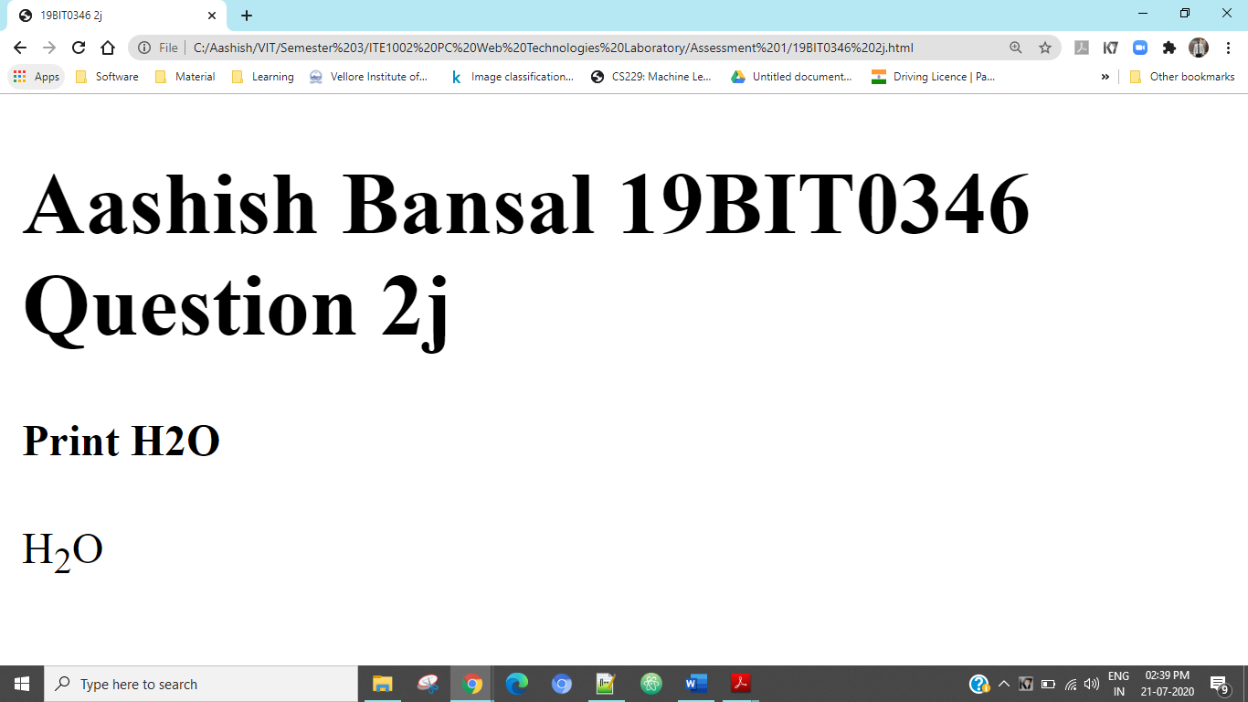

### Code Screenshot

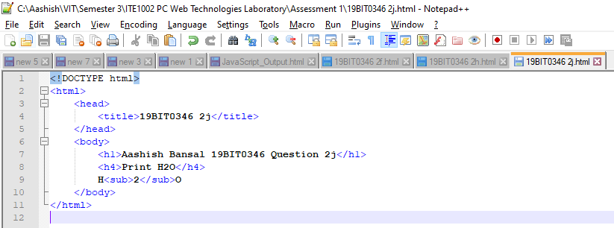

## Part k

Question:

Display a c code as it is in the page

### HTML Code

<!DOCTYPE html>

<html>

<head>

<title>19BIT0346 2k</title>

</head>

<body>

<h1>Aashish Bansal 19BIT0346 Question 2k</h1>

<h4>Display a c code as it is in the page.</h4>

<pre>

#include &lt stdio.h &gt

int main()

{

printf("Hello World!");

getch();

return 0;

}

</pre>

</body>

</html>

### Code URL

file:///C:/Aashish/VIT/Semester%203/ITE1002%20PC%20Web%20Technologies%20Laboratory/Assessment%201/19BIT0346%202k.html

### Output Screenshot

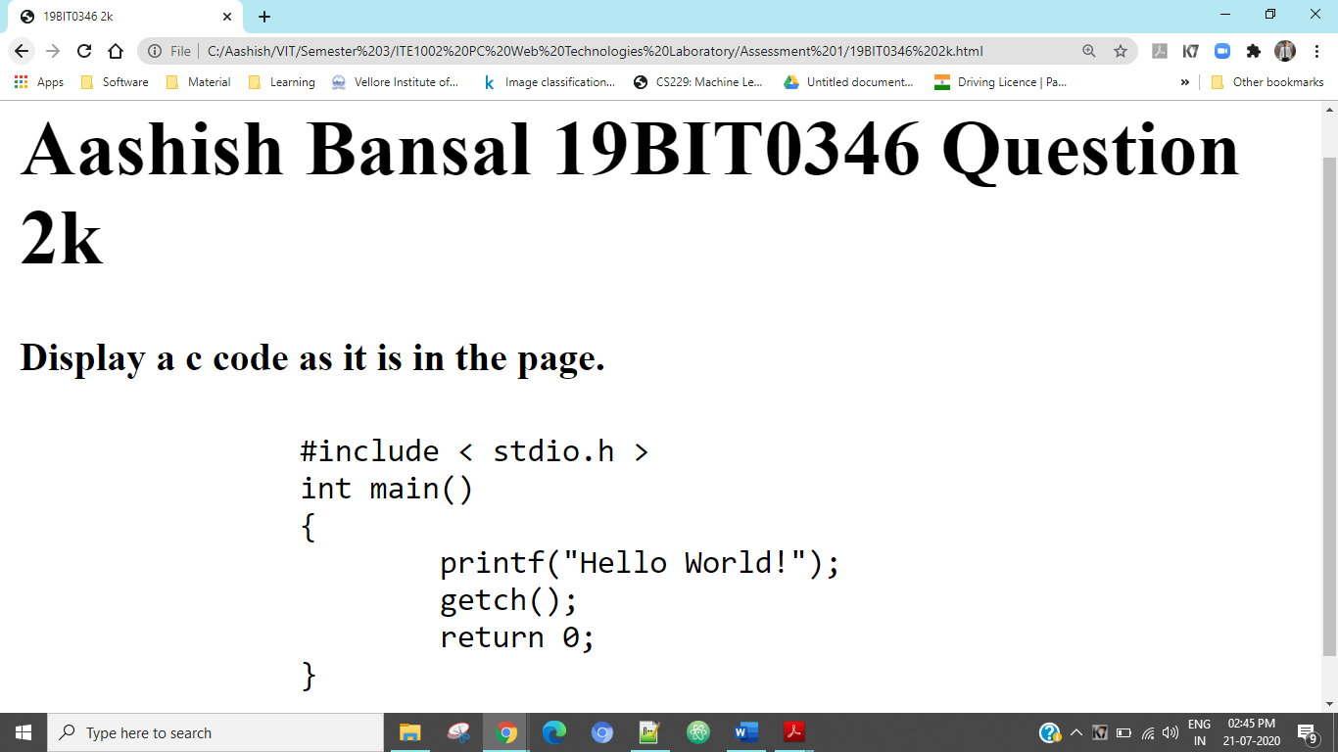

### Code Screenshot

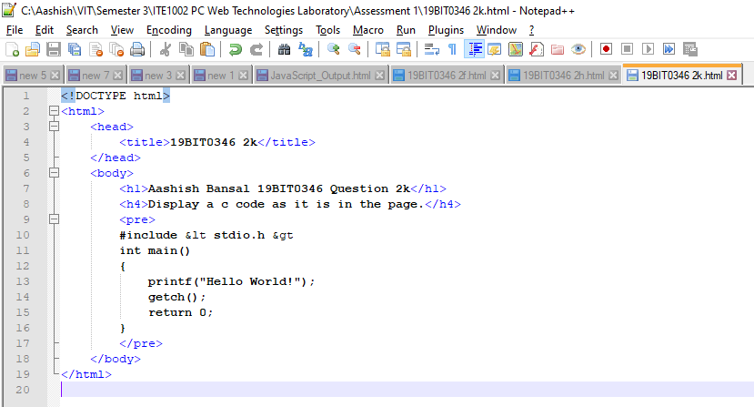

## Part l

Question:

Set the background color of the page as yellow.

### HTML Code

<!DOCTYPE html>

<html>

<head>

<title>19BIT0346 2l</title>

</head>

<body bgcolor="yellow">

<h1>Aashish Bansal 19BIT0346 Question 2l</h1>

<h4>Set the background color of the page as yellow.</h4>

</body>

</html>

### Code URL

file:///C:/Aashish/VIT/Semester%203/ITE1002%20PC%20Web%20Technologies%20Laboratory/Assessment%201/19BIT0346%202l.html

### Output Screenshot

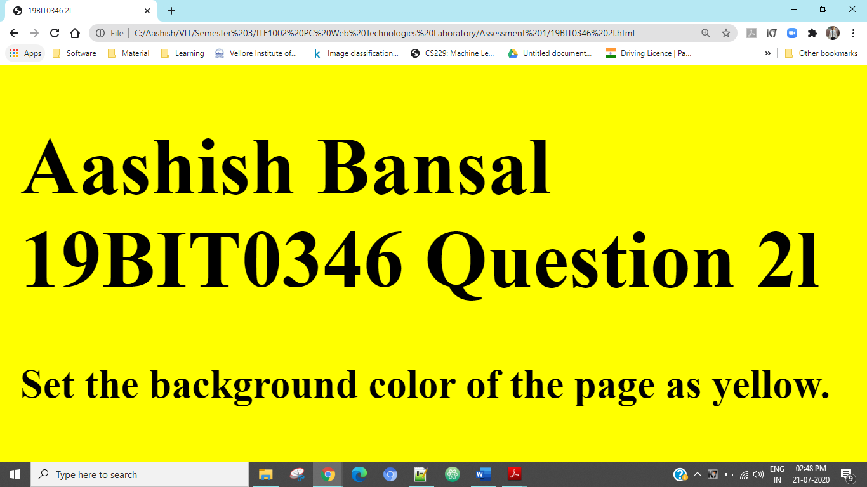

### Code Screenshot

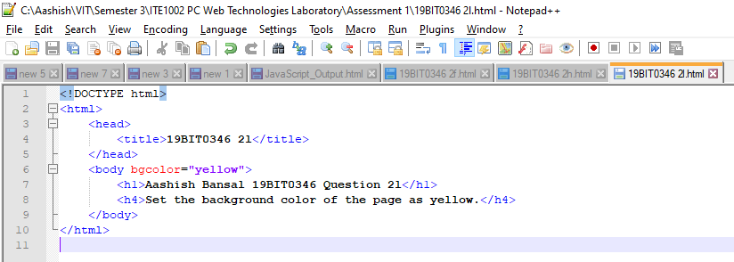

## Part m

Question:

Set an image as background of the page

### HTML Code

<!DOCTYPE html>

<html>

<head>

<title>19BIT0346 2m</title>

</head>

<body style="background-image: url('VIT-481x267.jpg');">

<h1>Aashish Bansal 19BIT0346 Question 2m</h1>

<h4>Set an image as background of the page.</h4>

</body>

</html>

### Code URL

file:///C:/Aashish/VIT/Semester%203/ITE1002%20PC%20Web%20Technologies%20Laboratory/Assessment%201/19BIT0346%202m.html

### Output Screenshot



### Code Screenshot

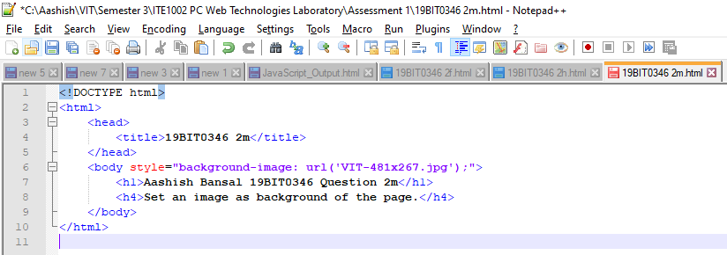

## Part n

Question:

Set the font size as 10. Print it. Again try to decrease the font size. Check whether the font size is reduced.

### HTML Code

<!DOCTYPE html>

<html>

<head>

<title>19BIT0346 2m</title>

</head>

<body>

<h1>Aashish Bansal 19BIT0346 Question 2m</h1>

<h4>Set the font size as 10. Print it. Again try to decrease the font size. Check whether the font size is reduced.</h4>

<p><font size="10">

<i>The Lord of the Rings</i>, fantasy novel by <i>J.R.R. Tolkien</i> initially published in <i>three</i> parts as <i>The Fellowship of the Ring (1954)</i>,

<i>The Two Towers (1955)</i>, and <i>The Return of the King (1955)</i>. The novel, set in the <i>Third Age</i> of Middle Earth, formed a sequel to Tolkien’s

<i>The Hobbit (1937)</i> and was succeeded by his posthumous <i>The Silmarillion (1977)</i>. The Lord of the Rings is the saga of a group of sometimes

reluctant heroes who set forth to save their world from <i>consummate</i> evil. Its many worlds and creatures were drawn from Tolkien’s extensive

knowledge of philology and folklore.

</font></p>

<br>

<p><font size="20">

<i>The Lord of the Rings</i>, fantasy novel by <i>J.R.R. Tolkien</i> initially published in <i>three</i> parts as <i>The Fellowship of the Ring (1954)</i>,

<i>The Two Towers (1955)</i>, and <i>The Return of the King (1955)</i>. The novel, set in the <i>Third Age</i> of Middle Earth, formed a sequel to Tolkien’s

<i>The Hobbit (1937)</i> and was succeeded by his posthumous <i>The Silmarillion (1977)</i>. The Lord of the Rings is the saga of a group of sometimes

reluctant heroes who set forth to save their world from <i>consummate</i> evil. Its many worlds and creatures were drawn from Tolkien’s extensive

knowledge of philology and folklore.

</font></p>

</body>

</html>

### Code URL

file:///C:/Aashish/VIT/Semester%203/ITE1002%20PC%20Web%20Technologies%20Laboratory/Assessment%201/19BIT0346%202n.html

### Output Screenshot

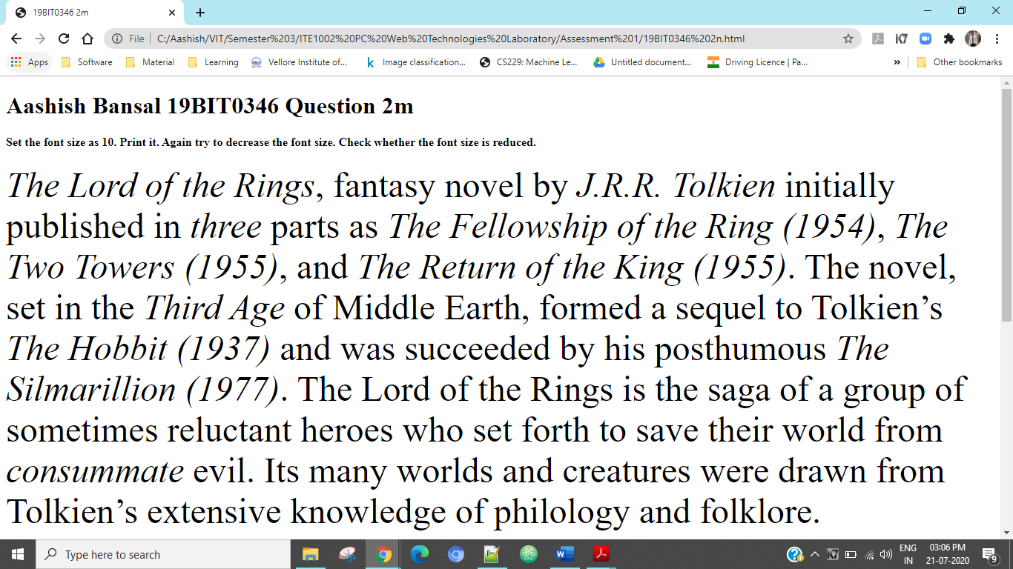

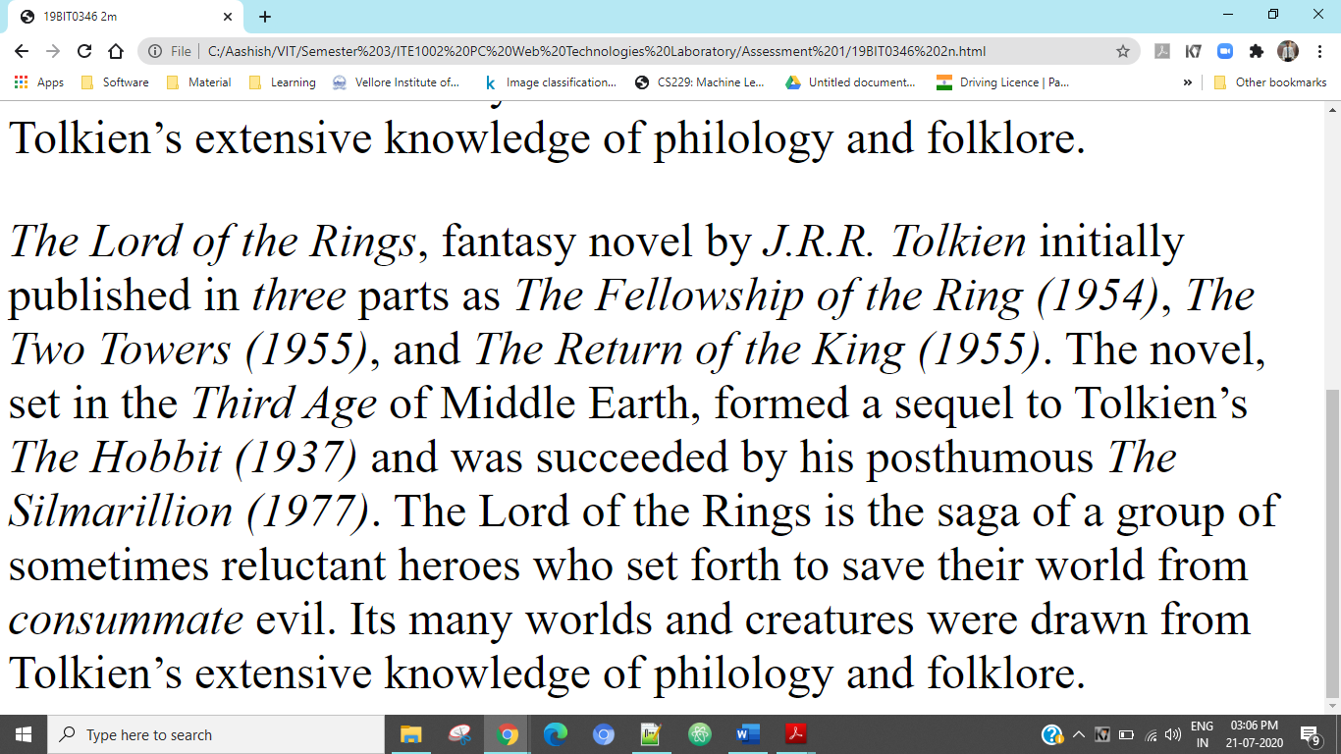

### Code Screenshot

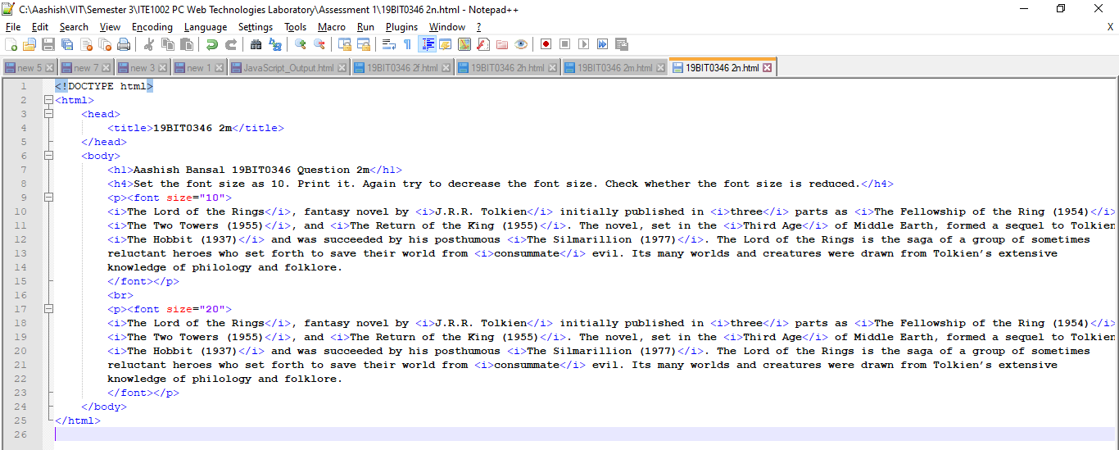

## Part o

Question:

Apply marquee for your name

### HTML Code

<!DOCTYPE html>

<html>

<head>

<title>19BIT0346 2o</title>

</head>

<body>

<h1>Aashish Bansal 19BIT0346 Question 2o</h1>

<h4>Apply marquee for your name.</h4>

<marquee>Aashish Bansal</marquee>

</body>

</html>

### Code URL

file:///C:/Aashish/VIT/Semester%203/ITE1002%20PC%20Web%20Technologies%20Laboratory/Assessment%201/19BIT0346%202o.html

### Output Screenshot

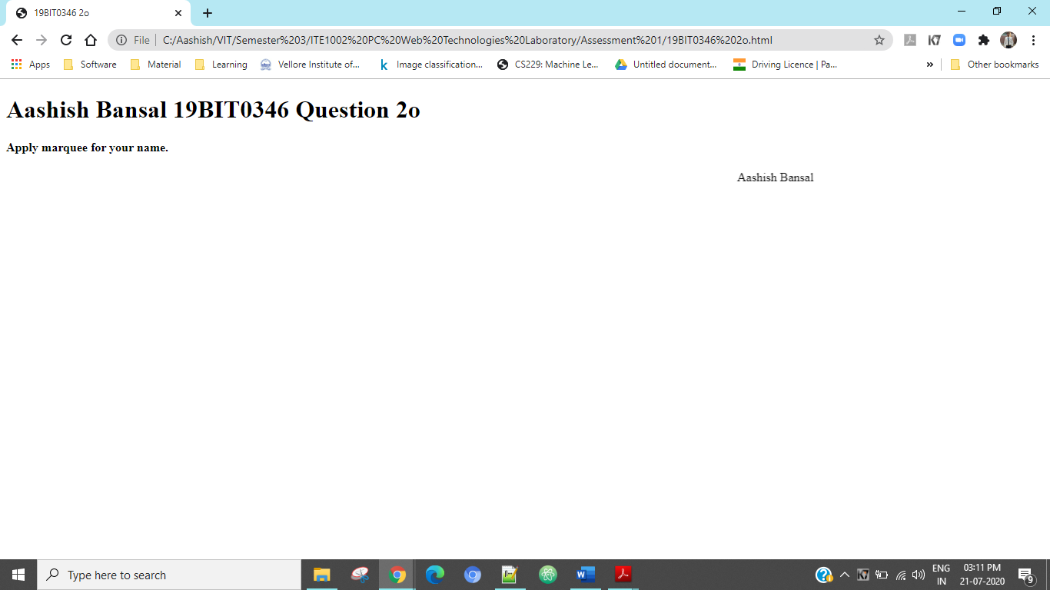

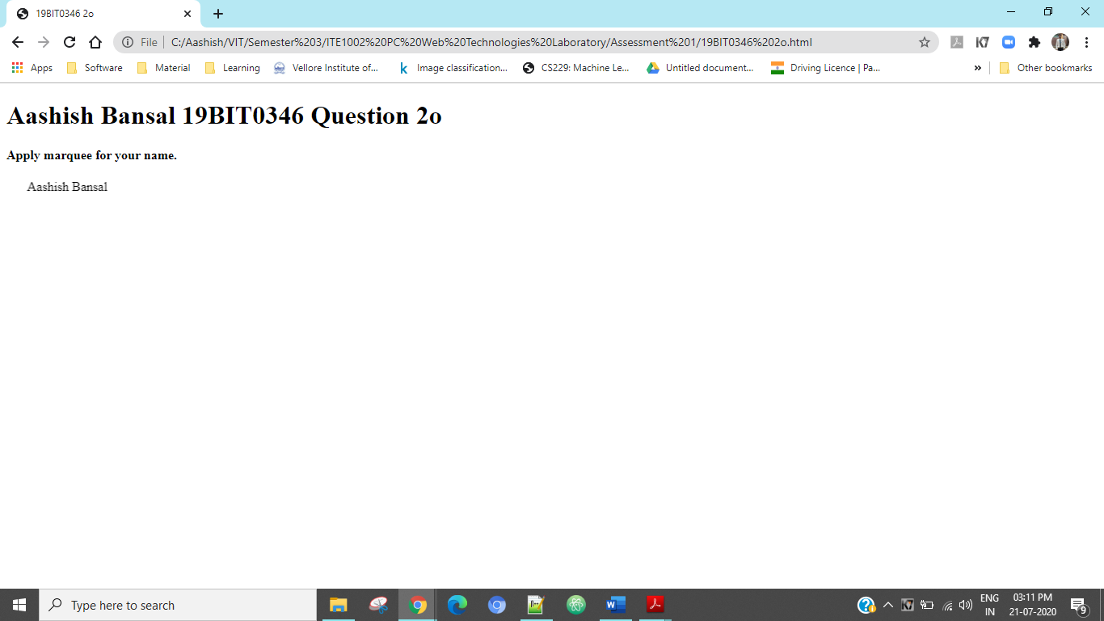

### Code Screenshot

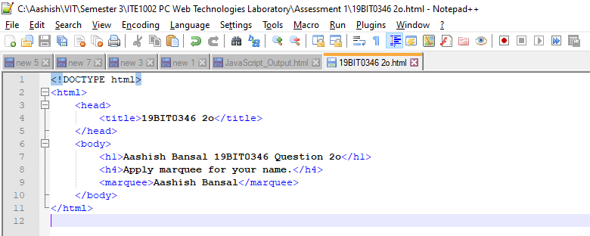

## Part p

Question:

Display a paragraph contents in a single line.

### HTML Code

### Code URL

### Output Screenshot

### Code Screenshot